Sprint 1 Architecture and Data Models

P07: Automated Compliance Auditing Software integrated using Ai

Student ID | Name
25100277 | Ammad Akram Khan
25100132 | Shabbir Kamal
25100259 | Saad Liaquat
25100279 | Rida Amir
25100162 | S. M. Aqdas Rizvi

Table of Contents
1. Introduction 3
2. System Architecture 4
2.1 Frontend Layer 4
2.2 Backend Layer 5
2.3 Database Layer 5
2.4 Scripts Layer 5
2.5 Data Flow and Interaction 6
2.6 Key Features 6
3. Data Models 7
3.1 Users Table 7
3.2 Documents Table 8
3.3 Controls Table 8
3.4 Relationships 8
3.5 Key Features 9
4. Tools and Technologies 10
4.1 Frontend 10
4.2 Backend 10
4.3 Database 10
4.4 Python Scripts 11
4.5 DevOps and Security 11
4.6 Tools and Frameworks 11
4.7 Communication 11
4.8 Key Advantages 12

Introduction

Overview: ACASA (Automated Compliance Auditing Software using AI) aims to automate the auditing of compliance standards such as HIPAA, ISO 27001, PCI-DSS, and GDPR. It utilizes open-source libraries and AI-driven decision-making to address current market gaps, particularly by offering a cost-effective, fully automated solution. ACASA targets organizations needing to streamline compliance processes, reducing human intervention and error, while improving audit accuracy and efficiency.
Potential Users:
- Compliance Officers
- IT Security Teams
- Executives
- Auditors

System Architecture

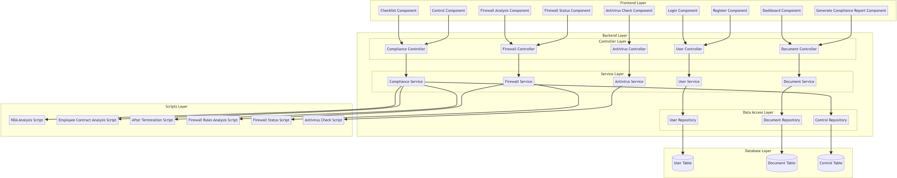

Frontend Layer
- The Frontend Layer is responsible for user interaction and presenting the application interface. It is implemented using React.js and consists of modular components:
- Login Component: Manages user login functionality.
- Register Component: Handles user registration.
- Dashboard Component: Displays the compliance checklist and system status overview.
- Checklist Component: Lists all compliance controls and allows users to check or upload necessary files.
- Control Component: Handles specific compliance control operations, including automation.
- Generate Compliance Report Component: Displays a compliance report with completion percentages.
- Firewall Analysis Component: Fetches and displays whitelist and blocked site rules from the backend.
- Firewall Status Component: Retrieves and displays the current firewall status.
- Antivirus Check Component: Fetches and displays information about installed antivirus software.
- Communication with the backend is achieved through RESTful APIs.

Backend Layer
- The backend is implemented using Node.js and Express.js. It follows a layered architecture for modularity and maintainability. This layer consists of:
- Controller Layer:
- User Controller: Manages user-related operations like registration and login.
- Document Controller: Handles file upload operations and document metadata storage.
- Compliance Controller: Orchestrates compliance verification workflows.
- Firewall Controller: Handles firewall configuration and status analysis.
- Antivirus Controller: Manages antivirus checks.
- Service Layer:
- User Service: Implements the business logic for user management.
- Document Service: Processes document-related logic and interacts with repositories.
- Compliance Service: Coordinates compliance checks, triggering Python scripts when necessary.
- Firewall Service: Handles the logic for analyzing firewall rules and status.
- Antivirus Service: Manages antivirus verification logic.
- Data Access Layer:
- User Repository: Interfaces with the User table for CRUD operations.
- Document Repository: Handles operations on the Document table.
- Control Repository: Provides access to compliance control configurations.
• /third-party-cookies: This route initiates the third-party cookie check by executing the Python script test_third_party_cookies.py, which verifies whether third-party cookies are blocked in Incognito mode.
• /malicious-phishing-site: This route triggers the malicious_site_check.py script, which detects phishing or malicious websites.
- /adblocker-check - Checks if an Adblocker is enabled using a Python script (adblocker_check.py).
- /rate-limit-safe-browsing - Applies rate-limited checks to detect excessive browsing and attacks with a Python
- safe-browsing: checks if safe browsing is enabled

Database Layer
- This layer uses PostgreSQL to persist application data. It contains:
- User Table: Stores user credentials and metadata.
- Document Table: Keeps records of uploaded documents, including file paths and associated control IDs.
- Control Table: Maintains a list of compliance controls with their respective IDs and descriptions.

Scripts Layer
- Python scripts are used for detailed analysis and specific compliance checks:
- NDA Analysis Script: Validates confidentiality agreements within uploaded documents.
- Employee Contract Analysis Script: Analyzes employee contracts for compliance-related clauses.
- After Termination Script: Checks for post-employment responsibilities in contracts.
- Firewall Rules Analysis Script: Retrieves and categorizes firewall rules into whitelist and blocked site lists.
- Firewall Status Script: Checks if the system firewall is enabled and its configuration.
- Antivirus Check Script: Identifies installed antivirus software and verifies security applications.

Data Flow and Interaction
- Frontend to Backend:
- The frontend components make API calls to the respective controllers in the backend for actions like user login, file uploads, or fetching system status.
- Backend Logic:
- Controllers validate incoming requests and delegate business logic to the respective services.
- Services interact with the data access layer to fetch or store data and may invoke Python scripts for compliance analysis.
- Backend to Database:
- The data access layer performs CRUD operations on the PostgreSQL database.
- Backend to Scripts:
- Python scripts process uploaded files or system configurations, returning results to the backend services, which relay them to the frontend.

Key Features
- Separation of Concerns:
- Each layer has a distinct responsibility, improving modularity and maintainability.
- Extensibility:
- New compliance controls or checks can be added by updating the database, scripts, and frontend components.
- Reusability:
- The service and repository layers are designed for reuse across multiple controllers and operations.
- Scalability:
- The layered architecture allows independent scaling of the frontend, backend, and database as needed.

Data Models

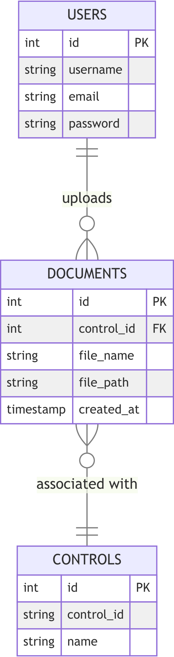

Users Table
- Purpose: Stores information about registered users of the system.
- Fields:
- id (Primary Key): A unique identifier for each user.
- username (String): The username chosen by the user during registration.
- email (String): The user's email address, used for login and communication.
- password (String): The user's password, stored securely (assume hashing for real-world applications).
- Relationships:
- A user can upload multiple documents (USERS has a one-to-many relationship with DOCUMENTS).

Documents Table
- Purpose: Stores metadata about uploaded documents and their association with compliance controls.
- Fields:
- id (Primary Key): A unique identifier for each document.
- control_id (Foreign Key): References the id in the CONTROLS table, indicating which compliance control the document relates to.
- file_name (String): The name of the uploaded file.
- file_path (String): The file's storage location on the server.
- created_at (Timestamp): The date and time when the document was uploaded.
- Relationships:
- Each document is linked to a specific compliance control (DOCUMENTS has a many-to-one relationship with CONTROLS).

Controls Table
- Purpose: Stores information about compliance controls.
- Fields:
- id (Primary Key): A unique identifier for each compliance control.
- control_id (String): The control's unique identifier (e.g., "6.1" for screening).
- name (String): A descriptive name of the compliance control (e.g., "Screening").
- Relationships:
- A compliance control can have multiple associated documents (CONTROLS has a one-to-many relationship with DOCUMENTS).

Relationships
- Users and Documents:
- A user can upload multiple documents, but each document is associated with one user.
- Documents and Controls:
- Each document is tied to a specific compliance control to ensure proper auditing and compliance tracking.
- Controls:
- Acts as a reference table for predefined compliance controls, enabling structured management of compliance requirements.

Key Features
- Normalized Structure:
- The design ensures minimal redundancy and organized data storage.
- Scalability:
- The structure supports additional compliance controls or documents without changes to the existing schema.
- Data Integrity:
- Relationships between tables (e.g., foreign keys) enforce referential integrity.

Tools and Technologies

Frontend
- React.js:
- A JavaScript library for building user interfaces.
- Used to create modular, reusable components for the application's frontend.
- Implements routing through react-router-dom to navigate between pages like login, dashboard, and compliance reports.
- CSS:
- Used for styling the frontend components and providing a responsive and user-friendly interface.
- Frontend Components:
- Components such as Login, Register, Dashboard, Checklist, FirewallAnalysis, and AntivirusCheck enable user interaction and data visualization.

Backend
- Node.js:
- A JavaScript runtime used to build the backend of the application.
- Handles API requests from the frontend and manages business logic.
- Express.js:
- A web application framework for Node.js.
- Used for setting up RESTful APIs and routing requests to the appropriate handlers.
- Multer:
- A middleware for handling file uploads.
- Processes uploaded documents and stores metadata in the database.
- Child Process Module:
- Utilized to execute Python scripts for compliance checks and system analyses.
- Environment Variables:
- Managed using dotenv to store sensitive information like database connection strings securely.

Database
- PostgreSQL:
- A relational database management system.
- Used to store user data, compliance controls, and document metadata.
- pg (Node.js PostgreSQL Client):
- Used to connect to the PostgreSQL database and execute queries.

Python Scripts
- Python:
- Executes compliance and system analysis tasks.
- PyPDF2:
- A library for reading and extracting text from PDF files.
- Used in scripts like NDA_contracts.py and employee_contracts.py.
- Subprocess Module:
- Executes system commands for retrieving firewall rules, status, and antivirus checks.
- OpenAI API:
- Utilized for intelligent analysis of documents (e.g., compliance with specific policies).
- Platform Module:
- Determines the operating system for platform-specific checks (e.g., firewall configuration).
- JSON:
- Formats script output for consistent communication with the backend.

DevOps and Security
- CORS (Cross-Origin Resource Sharing):
- Configured to allow communication between the frontend (http://localhost:3000) and backend (http://localhost:8000).
- Environment Variables:
- Securely manage sensitive data such as API keys and database credentials using .env files.

Tools and Frameworks
- BrowserRouter (React Router):
- Provides navigation between application pages in a single-page application.
- Postman:
- Likely used for testing API endpoints during development.
- Jest:
- Imported for potential unit testing of frontend components.

Communication
- RESTful APIs:
- Provides a communication bridge between the frontend and backend.
- Routes such as /register, /login, /upload, and /firewall-status enable seamless integration.

Key Advantages
- Scalability:
- Modular design and use of scalable technologies like Node.js and PostgreSQL.
- Maintainability:
- Separation of concerns between frontend, backend, and scripts ensures easy debugging and updates.
- Extensibility:
- Supports the addition of new compliance checks, frontend pages, or backend APIs without major restructuring.

